Kids’ Prophecy Corner

Daniel 11:40-45
The Original Intents

Welcome to the Kids’ Prophecy Corner.
Today we will look at the original intent of Daniel 11:40-45. In our last presentation we saw how Daniel 11:40 applies to our time. In fact, the rest of the chapter applies to our time. However it is an application of the verses which allows us to place it in the present. The current understanding of these verses is not their original intent. We need to understand how the pioneers interpreted these verses in their time.
There are two pioneer understandings of these verses. The first came from Josiah Litch. He wrote his interpretation in a book called An Address To The Public And Especially The Clergy (APEC). He wrote it in 1841. The second came from Uriah Smith in his book Daniel And The Revelation (D&R) that was published in 1882. Most Adventists are familiar with Smith’s book because sister White endorsed it seven times in her writings.
Now, what we need to understand is that both authors wrote their views according to the context they were living in; or what we commonly call their dispensation. For Litch the end of the world was arriving in 1843, then 1844. So, he wrote with that in mind. In Smith’s time the end of the world would have been around 1888.

1888
1882
1863
1841
Dan. 11 :40-45

D&R
(Smith)
APEC (Litch)

What is interesting between both versions is that they are identical for verses 40, 41, 42, and 43; and then diverge in their meaning in verses 44 and 45.
44
45
APEC (J. Litch)
41
42
43
40
Dan. 11 :40-45

D&R (U. Smith)

44
45

Let us explore!
Let us start with Uriah Smith’s version because most Adventists know it.
Daniel 11:40
And at the time of the end shall the king of the south push at him: and the king of the north shall come against him like a whirlwind, with chariots, and with horsemen, and with many ships; and he shall enter into the countries and shall overflow and pass over.
For Uriah Smith there are three characters involved: The king of the North (Turkey), the “him” (France), and the King of the South (Egypt)

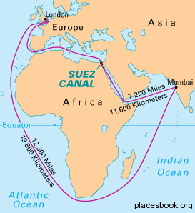
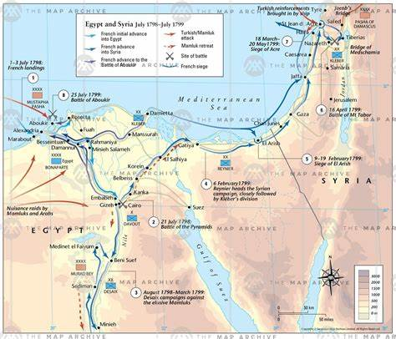
At the time of the end and the Pope was taken captive by General Berthier (February 10, 1798). But there is more to understand here. Napoléon was in conflict with England and wanted to cut its supply chain from India, its most important colony. In order to accomplish that he wanted to conquer Egypt. This would have enabled him to block the way of the English ships to reach India through the gulf of Suez and the red sea. So Napoléon conquered Egypt. Egypt tried to “push back” but it did so in vain. This frustrated Turkey who did not want to see Egypt become a French province. Turkey declared war against France on September 11, 1798 ¹ ². Turkey the king of the south, “came against him” (France) like a whirlwind; or we could say with much more strength than Egypt did. He overflowed and passed over by taking back all the territories that France had conquered.

Daniel 11:41
He shall enter also into the glorious land, and many [countries] shall be overthrown: but these shall escape out of his hand, [even] Edom, and Moab, and the chief of the children of Ammon.
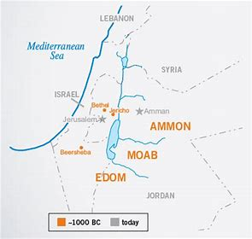
When reconquering the territories taken by France Turkey took back Palestine – The glorious land. The “many countries” are the provinces of Palestine. Edom, Moab and Ammon are Arab regions bordering Palestine. The Ottoman Empire was never able to conquer them. Rather than conquer them the Ottomans paid them an annual fee for the Arabs to allow free passage of trade caravans³.

Daniel 11: 42
He shall stretch forth his hand also upon the countries: and the land of Egypt shall not escape.
France was in a war on two fronts. In Europe and in Egypt. In Europe, France was at war with Austria, Britain, and Russia. Because of that the country was weakened. It ended up in a civil war which led to the government being dismantled. In Egypt the Turks assassinated French General Kleber and took back Cairo and Alexandria. This led to a peace treaty which was signed in London on October 1, 1801. Thus the war against France that started in 1798 finally ended in 1801⁴.

Daniel 11:43
But he shall have power over the treasures of gold and of silver, and over all the precious things of Egypt: and the Libyans and the Ethiopians [shall be] at his steps.
After reconquering Egypt the Turks let them manage their own affairs. But they imposed a large tribute to be paid annually. The Libyans and the Ethiopians were Arab tribes that sought the friendship of the Turks. These also paid tribute to the Turks⁵.

Daniel 11:44
But tidings out of the east and out of the north shall trouble him: therefore he shall go forth with great fury to destroy, and utterly to make away many.
Turkey declared war on Russia in 1853. They were both interested in the Danube which was an important conduit for trade. Russia was pressuring Turkey. But in doing so, the commerce of England and its strategic interests in the Middle East and India were threatened. France’s interests in this region were also threatened. Turkey fought with “great fury” but also sought the help of England and France. This resulted in a peace treaty in 1856 – The treaty of Paris. This was the Crimean war of 1853-1856⁶.

Daniel 11:45
And he shall plant the tabernacles of his palace between the seas in the glorious holy mountain; yet he shall come to his end, and none shall help him.
From Uriah Smith’s perspective the literal application of this verse was in the future. Palestine, which contains the “glorious holy mountain,” (Jerusalem), which sits “between the seas” (the Dead sea and the Mediterranean sea) is a Turkish province. In the event that the Turks had to retreat from Europe they could establish a temporary headquarters “tabernacles” and “palaces”) in Jerusalem.⁷
Uriah Smith’s interpretation was correct for his generation. If Christ came back in the 1888 time period the last verse would have been fulfilled as expected.
As we mentioned before, Smith and Litch have the same understanding for verses 40, 41, 42 and 43. In fact, Uriah smith used Litch’s work to write his book Daniel and The Revelation. The reason why they come to different conclusions for verses 44 and 45 is because the dispensation in which they wrote is different. Litch was part of the first generation of Adventism. Smith was part of the second. So their views of what was happening in the world were different.

Daniel 11:44
But tidings out of the east and out of the north shall trouble him: therefore he shall go forth with great fury to destroy, and utterly to make away many.
For Josiah Litch, the “him” is France or Napoléon. Napoleon received news out of the east and out of the north that troubled him. This news was an account of the failure of his Syrian campaign (the north) and the failure of his East-India campaign (the East). Because of that he had to leave Egypt and return to France leaving behind a helpless and feeble army.
All Napoléon’s conquests and defeats came with a great sacrifice of human life. Hundreds of thousands of his soldiers perished in additions to hundreds of thousands of his enemies. Hence, he did “utterly make away many”⁸.

Daniel 11:45
And he shall plant the tabernacles of his palace between the seas in the glorious holy mountain; yet he shall come to his end, and none shall help him.
Josiah Litch applied this verse to the battle of Waterloo which took place on June 18, 1815. Following his defeat Napoleon had no choice but to abdicate the throne of France. He voluntarily surrendered himself into the hands of the British. He was exiled on the Island of St. Helena. On May 21, 1821 Napoléon died while a dreadful storm was occurring on the island. It is thus that he came to his end and there were none to help him⁹.
Josiah Litch views was correct for his generation.
In review, we have these two views of Daniel 11; especially verses 44 and 45.

 | Josiah Litch (APEC) - 1841 | Uriah Smith (D&R) - 1882
V.44 | “Him” = Napoléon  Tidings = news from his Syrian and East- India campaigns | Turkey and the Crimean war (1853-1856)
V.45 | Battle of Waterloo (1815). Napoléon abdicates.  Died on May 1821 with no help | Future fulfilment. Turkey’s Temporary headquarters would be in Jerusalem

Both views are correct when put in their proper context. Taking their understanding into consideration allows us to comprehend other subjects correctly. Particularly the subject of Islam (Revelation 9). Litch understood the first and second woe correctly which allowed him to predict the fall of the Ottoman empire on August 11, 1840. We can go back to the histories surrounding this time period (the 10-year Syrian war (1831-1841)) and draw some conclusions for our time.
We have wrongly in the past stated that Uriah Smith (and ultimately Litch) were wrong on Daniel 11:40-45. We made a mistake. God is showing us that although there are different interpretations of these verses for each generation in which Christ was to come, we cannot reject them. If we do so we reject our understanding of Islam which was given by them. So instead of denying the original intent of these verses we need to study them more closely to better understand our time.

References:
1.DAR1909 304.1-2; 2.http://www.emersonkent.com/history/timelines/french_revolutionary_wars_timeline_1798.htm
3. DAR1909 307.1-3
4. DAR 1909 308.1-3
5.DAR1909 309.1-4
6.DAR1909 309.5; www.history.com/topics/british-history/crimean-war
7. DAR1909 311.2
8. APEC 101.4-5; 102.1-2
9. APEC 102.3-4; 103.1-2

