Kids’ Prophecy Corner

The Parable of the Mustard Seed

Welcome to Kids’ Prophecy Corner. Today, we will look at the Parable of the Mustard seed found in Matthew 13: 31,32; Mark 4: 30, 32 and Luke 13: 18, 19.

Let’s us start with a word of prayer.

Let us turn to Matthew 13: 31, 32

13:31 Another parable put he forth unto them, saying, The kingdom of heaven is like to a grain of mustard seed, which a man took, and sowed in his field:
13:32 Which indeed is the least of all seeds: but when it is grown, it is the greatest among herbs, and becometh a tree, so that the birds of the air come and lodge in the branches thereof.

Let us now read Mark 4:30, 32

4:30 And he said, Whereunto shall we liken the kingdom of God? or with what comparison shall we compare it?
4:31 It is like a grain of mustard seed, which, when it is sown in the earth, is less than all the seeds that be in the earth:
4:32 But when it is sown, it growth up, and becometh greater than all herbs, and shooteth out great branches; so that the fowls of the air may lodge under the shadow of it.

Let us turn to Luke 13: 18, 19
13:18 Then said he, Unto what is the kingdom of God like? and whereunto shall I resemble it?
13:19 It is like a grain of mustard seed, which a man took, and cast into his garden; and it grew, and waxed a great tree; and the fowls of the air lodged in the branches of it.

The first question we should ask ourselves is when and where did Jesus give this parable? The answer is found in Matthew 13:1 and Matthew 12:1. It is on the seaside and on a Sabbath.

The theme of this parable is the kingdom of Heaven. What it looks like and how it is ruled.

If we compare the 3 chapters where the parable is mentioned, we can find a lot of common imagery. Jesus uses nature to illustrate the kingdom of heaven.
Here is what we find:

Matthew 13: 31-32 | Mark 4:30-32 | Luke 13: 18-19
Kingdom of Heaven | Kingdom of God | Kingdom of God
Field | Earth | Garden
Grain of Mustard seed | Grain of mustard seed | Grain of mustard seed
Herb | herbs | X
Tree | X | Great tree
Branches | Great branches | Branches
Birds | Fowls | Fowls
Least | Less | X
Greatest | Greater | Waxed great
Lodge | Lodges | Lodge
X | shadow | X

So, what can we learn from all these images? Well, we will need to define each word in order to really understand what Jesus wants to teach the disciples and the crowd and also us.

First, there is the work of the sower. To sow a seed, you need a field or a garden or a ground -the earth. Once you have the proper conditions (the weather), you can plant your seed. It is very important because, you want the seed to grow properly, you want good fruits.

The mustard seed that is planted is the kingdom of heaven. We know it because the parable says, the kingdom of heaven is like. This shows that Jesus compares the kingdom to the mustard seed.
So, this kingdom will grow progressively to become a huge kingdom that will be strong and represent the character of Christ.

Also, the mustard seed is a symbol of faith and it shows how faith works. Even if you have a tiny amount of faith, you can do big things like conquering the world, if you really believe of course.

Matthew 17: 20-21
17:20 And Jesus said unto them, Because of your unbelief: for verily I say unto you, If ye have faith as a grain of mustard seed, ye shall say unto this mountain, Remove hence to yonder place; and it shall remove; and nothing shall be impossible unto you.
17:21 Howbeit this kind goeth not out but by prayer and fasting.

Luke 17:5-6
17:5 And the apostles said unto the Lord, Increase our faith.
17:6 And the Lord said, If ye had faith as a grain of mustard seed, ye might say unto this sycamine tree, Be thou plucked up by the root, and be thou planted in the sea; and it should obey you.

The Tree

Now, the tree is another symbol used. Jesus compares it to an oak tree because, the oak tree is a symbol of strength and safety. It provides a shelter and a protection. This is why the birds come lodge in it. So, it gives a service to others. The tree also stands alone, which is important because it is like the faith. The faith is not dependant of other. You have to stand alone.
And the tree is the kingdom itself because it is the mustard seed that grew to a full plant.
Another purpose of the tree is that it has leaves and fruits. So, it can provide food to others and it can promote health. It helps you to heal. Just like the tree of life mentioned in Revelation 22:2.
22:2 In the midst of the street of it, and on either side of the river, [was there] the tree of life, which bare twelve [manner of] fruits, [and] yielded her fruit every month: and the leaves of the tree [were] for the healing of the nations.

Jesus also compares the leaves to promises. John 6:37 says, then grasp His promises as leaves from the tree of life: “Him that cometh to Me I will in no wise cast out.” John 6:37. As you come to Him, believe that He accepts you, because He has promised. You can never perish while you do this—never. {MH 65.4}

So, we can see this 2-fold purpose of feeding and healing.

Oh, by the way, a mustard tree can reach the height of 25 feet and an oak can reach 70 feet in size and 9 feet in width. Their branches can reach 135 feet in length.

So now, let’s talk about the branches.
The branches are mentioned in the three chapters. The branches are lines which will make us think of line upon line. They are also symbol of patriarchal system like a family tree. The roots are the patriarchs or the fathers and the branches are the descendants. And when you look from far, they form a chiasm. The roots are spread in water and the branches are spread to the world where they can be seen (this is why they waxed great) and where they can reach people.
Jesus, says, I am the vine, you are the branches, so, the branches can also represent people.

The Birds
The birds or fowls are a representation of gentiles. We can see that in the story of Noah. We can see that in the dream Peter had of unclean animals or in Revelation 18:2 when it talks about Babylon being full of unclean birds. And these birds come and lodge in the tree or the branches.

Least, great/greatest
Now, we have the adjectives: Least to great/greatest – Jesus tries to remove any preconceived ideas the Jewish people have. The gentiles are considered the least of the people in their mind but the least has its dwelling place in the church triumphant. On an individual level, Jews think they are the greatest, and as a nation they think they are the best. They have a problem with the nature of Christ and also the nature of man. They have a problem with equality and Jesus wants to show them that in his kingdom, you cannot have inequality. He loves everyone and there is a place for everyone.

So, to summarize, Jesus illustrates his kingdom by using the concept of natural and spiritual. He wants to draw the attention of his disciples on how his kingdom looks likes. The kingdom, which is the seed becoming the tree, is the church triumphant. And its mission will be a success because the birds – which are the gentiles or the world – can come and lodge in it. This tree is strong, it provides stability because it is a dwelling place, a resting place. It is a place where the least becomes the great which means that there is freedom, there is no inequality, there is no oppression. Everyone, especially the birds – the gentiles - can trust this place (this is why they lodge under the shadow of it.) shadow is a symbol of trust. You can find it in Judges 9:8-15)
9:15 And the bramble said unto the trees, If in truth ye anoint me king over you, [then] come [and put your trust in my shadow: and if not, let fire come out of the bramble, and devour the cedars of Lebanon.

This why the tree is represented also by an oak tree. Because, if you look at its branches, some are high, and some touch the ground. So, even the smallest bird who doesn’t fly high or the chicken can reach the branches. Jesus wants everyone to experience this equality no matter the size or species.

For the Jews, it is hard to hear, but the kingdom and the king is not only for their nation. God has special people in all races and nations.

Now, if we have to apply this parable to us what can we understand?

First, Jesus is using the agricultural model, so we have a point of start. In the agricultural model, we have the ploughing, the early rain, the latter rain and the harvest.

On the line of the 144K, the ploughing is from 1989 to 9/11; the early rain from 9/11 to Sunday Law; the latter Rain from Sunday law to Close of Probation and the harvest from Close of probation to the second advent.

The parable mentions the sowing of the seed and the tree fully grown. It also talks about the herb.

The sowing, happens after the ploughing, so it is at 9/11. Then it becomes an herb and then it becomes a big tree.
The big tree must be placed between Sunday Law and Close of probation for two reasons:
- First, to become big and to provide food and shelter, it needs the latter rain. This is when the tree can mature, and the fruits ripen.
- Second, the birds come and lodge in it. The birds are the gentiles or the world. And we know that it is at the Sunday Law that the world comes join the church.

The seed is a message. It is parable teaching, line upon line or how to understand the prophecies at the end of the world.
God is using a message and messengers to remove all preconceived ideas from the mind of his people so they can do a successful work at the Sunday Law by harvesting the world.
His seed or his descendant or his chosen people have to be free from homophobia, sexism, racism, superiority, nationalistic mindset. They have to STOP worship a god they made in their own image, thinking that God wants you to treat others differently.
Instead, by using right methodology, they have to make sure they have a good working knowledge of GOD and they will listen and worship the true God not the one they created in their mind. So, there is a lot of branches of false doctrines that would need to be removed, even broken to be replaced by true doctrines given line upon line.
When, this is done in the church, then, the tree will be beautiful and big enough so the world can see it and trust us enough to join the church Triumphant. They will understand the message we will give them but most important they will see the true character of GOD. And so, their faith will be solid to stand after the Close of Probation during Jacob’s Time of Trouble. And they will see and live with Jesus forever! Amen.

DN 12:1
144K
SL
COP
1989
2001
2nd Advent

. = truth
= line upon line
Prepare the way
Early Rain
Latter Rain
Harvest
Plough
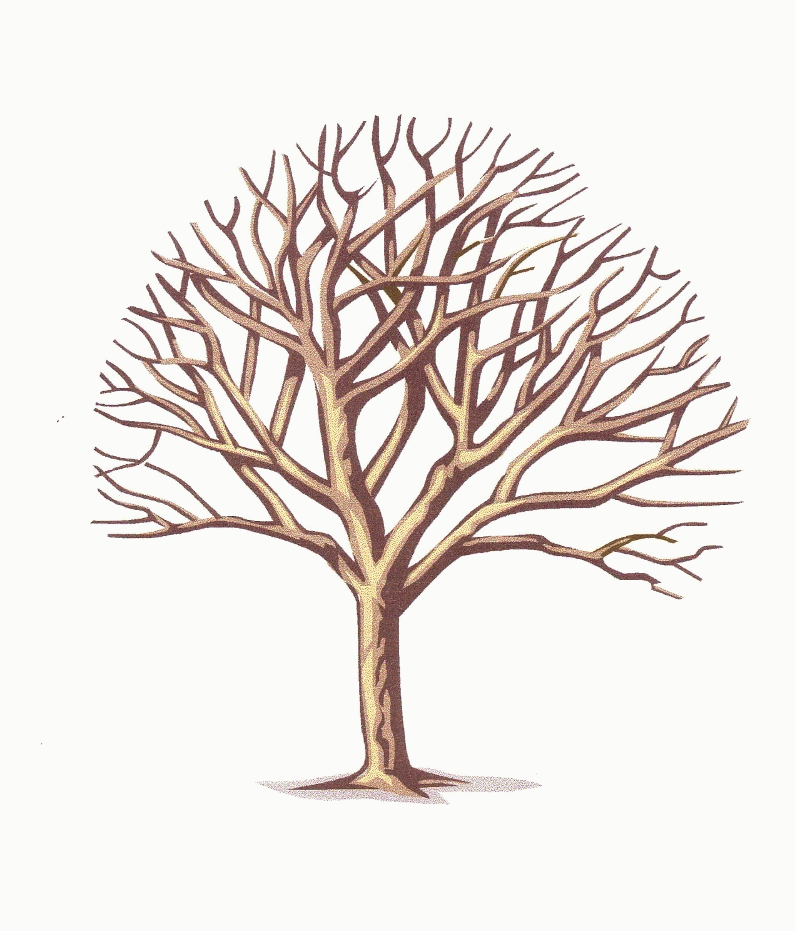
Branches = body of doctricne, Knowledge, prophetic truth people
Message = truth
Messengers = people

Church
world
Sealing= settling into the truth both – intellectually (message)
and spiritually (character development experience)

