Kids’ Prophecy Corner

The Impeachment Process of Donald Trump

Welcome to Kids’ Prophecy Corner.
Today we will look at the Impeachment of Donald Trump.
We will first look at how the impeachment of a president takes place and what is an impeachment.
Then, we will ask ourselves why we look at impeachment.
We will look at Andrew Johnson, Richard Nixon and Bill Clinton.
Finally, we will look at Donald Trump’s Impeachment process.

How to Impeach a President
When America’s founding fathers were debating how to set up a brand-new government, they ran into a problem: What should happen if a president, in Benjamin
Franklin’s words, has “rendered himself obnoxious?”

Most countries didn’t have elected leaders and ways to get rid of them, if necessary.
So, Franklin and the framers turned to a provision of British common law known as impeachment: Trial, conviction, punishment.

In Great Britain, impeachment could be brought against anybody, any citizen.
And it also could result in any punishment, including death.
So, they put impeachment in the constitution and then set up a whole series of unique American features in it.

The constitution lays out three offenses for which any federal official, including the
President can be impeached.
The first two, treason and bribery, are pretty straightforward.

Treason means helping enemies of the United States.

Bribery, taking money or gifts in exchange for a political favor.

And the last phrase, “other high crimes and misdemeanors”, is unique in the constitution. “High crimes and misdemeanors” have been treated as a sort of catch-all for either criminal activity or what Congress considers serious abuse of office.

Article II, Section 4 of the US Constitution details the impeachment power: “The President, Vice President and all civil Officers of the United States, shall be removed from Office on Impeachment for, and Conviction of, Treason, Bribery, or other high Crimes and Misdemeanors.”

For three U.S. presidents, Andrew Johnson, Richard Nixon, and Bill Clinton, the question
of whether to impeach and remove them from office centered around whether their behavior fit in this third category of high crimes and misdemeanors.

The process of Impeachment has to start in the House of Representatives.
Any member can introduce an impeachment resolution.

A resolution, that President George W. Bush be impeached for high crimes and misdemeanors did not go nowhere.

That’s because impeachment charges, have to be approved by a majority of the House
Judiciary Committee.

Next, the full House of Representatives votes on whether to impeach.

If a simple majority votes yes, the President is officially impeached.
But that doesn’t mean he loses the presidency. That decision happens in a Senate trial.

The Senators act as the jury. They hear evidence from both sides and if 67% of those Senators vote to convict, the President is removed from office.
This has never actually happened.

Andrew Johnson

In 1863, a House majority voted to impeach Andrew Johnson for firing is Secretary of
War. This was after months of conflict after Reconstruction following the civil war.
Johnson was only one vote short

Bill Clinton

The only other president impeached by the House was Bill Clinton in 1998.

The whole thing started when Clinton was sued for sexual harassment by a woman named Paula Jones, who worked for him when he was Governor of Arkansas.

In a deposition for that case, Jones’ lawyers asked Clinton if he’d had an affair with a different employee-- a White House intern named Monica Lewinsky.

Clinton said he hadn’t. He retracted himself and said: But that wasn’t true. I had intimate contact with her that was inappropriate.

Republicans in the house argued Clinton should be impeached for lying under oath because it was a public act not a private act.

Some say: What the defenders want to do is lower the standards by which we judge this president and lower the standards for our society by doing so.

Democrats disagreed that the offense was serious enough to be called a “high crime.”
At one point, they walked out of the chamber in protest.
Some say: There is one small segment on the far-right, who have lost all objectivity, and are determined to impeach the President at all costs.

But the resolution of the House was as followed:

“House Resolution 6 11, resolved, that William Jefferson Clinton, President of the United States is impeached, for high crimes and misdemeanors.”

During the Senate trial the votes were split almost completely by party.
Part of the disagreement within the Senate had to do with the context in which Clinton's
actions had taken place in public or in private.

At the end, the Senate voted him non-guilty.

We can read the following:
“The Respondent, William Jefferson Clinton, is not guilty as charged in the Senate article
of impeachment.”

But Clinton’s popularity didn’t really suffer. The American people didn’t demand that he be tossed out of office. Not a single Democratic Senator voted to remove Clinton from office. Typically, you need to have members of more than one party.

That is one of the major differences between Clinton’s case and President Richard Nixon’s.

Richard Nixon

Over the course of several months in 1973, members of Congress, and the American people, learned about Nixon’s possible involvement in a break-in at the offices of the Democratic National Committee (DNC)which was located in the Watergate office building. There were evidences of espionage and the president knowingly participated in the Watergate cover up.

By the time the charges had been shown to have some evidence supporting them, the public began to kind of render a judgement against Nixon, which was, his popularity plummeted.

That evidence only came out because Republicans, members of Nixon’s own party, in both the House and Senate, called for investigations into the President’s behavior.

In the House Judiciary Committee, Republicans joined with Democrats to approve Articles of Impeachment against Nixon. But Nixon resigned before the full house could vote on impeachment because Republican leaders had told him there was no way he’d survive which explains why no president has ever been removed from office by impeachment.

For that to happen, the president doesn’t just have to commit some high crime or misdemeanor. He has to lose the support his own party. In which case, history suggests he’ll see himself out.

Why Do We look At Impeachment?

Not only Christ declares the end from the beginning He is also Palmoni which means the “wonderful number” or “numberer of secrets”. This means that Christ oversees the numbers and they have a special prophetic significance like 490, 245, 220, 151, 126,81.
2019 is a significant year and when we take one of these numbers and subtract them from 2019, we learn something significant about that specific year.

To understand the impeachment of Trump we take the prophetic number 151. But where does it come from?

In Daniel 5:25 we are told :

5:25 And this [is] the writing that was written, MENE, MENE, TEKEL, UPHARSIN.

We get the time periods of 151 and 126 years from Daniel 5. The judgement pronounced against Belshazzar was written as Mene, Mene, Tekel, Upharsin. If we convert these words into monetary value, we can derive the 151 and 126. A Mene is worth fifty shekels. A Upharsin is worth half a Mene, or in this case, twenty-five shekels. A Tekel is worth one Shekel. So, if you add all the shekels up from Mene, Mene, Tekel, Upharsin, you come up with the sum of 126 Shekels. But, a Mene can also be worth sixty Shekels (Ezekiel 45:12). And this means that an Upharsin can be worth thirty Shekels. The sum is, therefore, 151. If you convert the 126 shekels into gerahs, the sum is 2520 gerahs (so one shekel is worth twenty gerahs). That is how the 126 and 151 represent the 2520, and so, they are significant time period.

Mene  Mene  Tekel  Upharsin | 50  50  1  25 | 60  60  1  30
 | 126 | 151

Now, the number 151 brings us to the year 1868. In 1868, Andrew Johnson is the president who is impeached.
151

1868
2019

Mr. Trump Impeachment process.
Premiere Reason:
Abuse of power – Trump Ukraine Scandal.
(Trump sought to use his powers of office to press Ukraine into doing political favors for him.)

1St Presidential Impeachment
Andrew Johnson
Premiere reason: firing Secretary of war Edwin M. Stanton and insulting congress

Andrew Johnson
At the outbreak of the Civil War in 1861, Andrew Johnson, a senator from Tennessee, was the only U.S. senator who remained loyal to the Union. In 1862, President Abraham Lincoln appointed him military governor of Tennessee, and in 1864 he was elected vice president of the United States.
After Lincoln’s assassination in April 1865, He was sworn as president of the United States. However, under his administration in 1865 and 1866 he favored new southern state legislatures and passed restrictive “black codes” to control the labor and behavior of former slaves and other African Americans. that preserved the system of slavery in all but its name.
The Republican-dominated Congress greatly opposed Johnson’s Reconstruction program and in March 1867 passed the Tenure of Office Act over the president’s veto. The bill prohibited the president from removing officials confirmed by the Senate without senatorial approval and was designed to shield members of Johnson’s Cabinet like Secretary of War Edwin M. Stanton, who had been a leading Republican radical in the Lincoln administration.
In the fall of 1867, President Johnson attempted to test the constitutionality of the act by replacing Stanton with General Ulysses S. Grant. However, the U.S. Supreme Court refused to rule on the case, and Grant turned the office back to Stanton after the Senate passed a measure in protest of the dismissal.
On February 21, 1868, Johnson decided to rid himself of Stanton once and for all and appointed General Lorenzo Thomas, an individual far less favorable to the Congress than Grant, as secretary of war.
On February 24, Johnson was impeached, and on March 13 his impeachment trial began in the Senate under the direction of U.S. Supreme Court Chief Justice Salmon P. Chase.
The U.S. House of Representatives votes 11 articles of impeachment against President Andrew Johnson, nine of which cite Johnson’s removal of Secretary of War Edwin M. Stanton, a violation of the Tenure of Office Act. The House vote made President Johnson the first president to be impeached in U.S. history.
The trial ended on May 26 with Johnson’s opponents narrowly failing to achieve the two-thirds majority necessary to convict him.

Richard Nixon and Bill Clinton
As mentioned at the beginning of our presentation, other presidents received a procedure of impeachment.
In 1974, Richard Nixon was headed toward being impeached for obstruction of justice and abuse of power related to the Watergate burglary cover up, but he resigned before it could happen.
In 1998, Bill Clinton was impeached for perjury and obstruction of justice for his effort to cover up his affair with Monica Lewinsky.
 | House Impeachment | Senate Trial | Senate Conviction
Andrew Johnson | - . | - . | X
Richard Nixon | X | X | X
Bill Clinton | - . | - . | X

Donald Trump

The reason why Trump is facing an impeachment inquiry is because of the Trump-Ukraine Scandal.
The Trump-Ukraine scandal began in September 2019 with the revelation that an intelligence officer had filed a whistleblower complaint to the intelligence community inspector general alleging wrongdoing on the part of Trump.
The complaint offers a damaging portrait of a president willing to use his office for political gain by asking Zelensky to investigate his political rivals — specifically former Vice President Joe Biden, and his son, Hunter Biden.
President Donald Trump used the “power of his office” to solicit help in the 2020 elections from Ukrainian President Volodymyr Zelensky and the Trump White House chose to voluntarily release an official record of the phone call with Zelensky.
Trump says that there is nothing wrong in the call, but the transcript shows otherwise.
Zelensky asked Trump for an increase in military aid — specifically, to purchase more Javelin anti-tank missiles, useful in Ukraine’s ongoing conflict with Russian-backed separatists in its east.
Trump responded by saying, “I would like you to do us a favor though.”
The favor turned out to be about two investigations Trump would like Ukraine to conduct: one involving a bizarre and unfounded theory about Ukrainian possession of a Democratic email server, the other an effort to smear the Biden family’s dealings with a Ukrainian prosecutor as corrupt.
Zelensky responds by asking specifically for the Javelin missiles, which Trump links to his desire for an investigation into Crowdstrike (which he wrongly believes to be owned by a wealthy Ukrainian) and “the server” he thinks Ukraine has.
Back when Joe Biden was vice president, the Obama administration was trying to support Ukraine in an ongoing conflict with Russia. The administration and its European allies decided that corruption among Ukrainian officials was a major impediment to strengthening Ukraine.
The Obama administration and its European allies, with Biden playing a significant role as an emissary on behalf of the United States, pressured Ukraine to reform. That pressure escalated to the point where the United States was holding up $1 billion in loan guarantees until the Ukrainians fired Shokin.
Crowdstrike has nothing to do with Ukraine. It’s an American company whose co-founder was born in Russia but emigrated to the US as a kid. Crowdstrike was hired by the Democratic National Committee to help investigate the hacking of their email during the 2016 campaign, and Trump is disturbed by the fact that the DNC did not turn a physical server over to the FBI or anyone else. Trump has time and again sought to exonerate Russia of culpability for computer crimes in 2016, and his interest in Crowdstrike seems to be part of that larger agenda.

For his defense Trump says:
- There was “no quid pro quo”. Trump first asserted that nothing inappropriate happened on the phone call with Zelensky (he calls it “perfect” repeatedly).
- We should “Get over it”. Trump says that they should stop making a big deal of it because it is normal in foreign policy for America to encourage another country to give it what Washington wants.
- It is a Hoax, it is witch-hunt, it is a lie, it is a shame, it is a fraud.
- It is a shame for American people.
- It is a disgrace and a mock for our country.
- He takes “zero” responsibility for Impeachment.
- On December 17, 2019, He sent a letter to the House speaker Nancy Pelosi denouncing articles of impeachment against him.
He says She violated her oath of office and that the impeachment is unconstitutional. It is an illegal partisan attempted coup.

Now, on December 10, 2019 the articles of impeachment were released and voted on December 12, 2019 the House of Judiciary voted two articles of impeachment: Abuse of power and obstructing congress on a vote 23-17.
On December 18, 2019, Trump is impeached for abuse of power and obstruction of Congress. Abuse of power because he used the power of presidency for his own benefit. Obstruction of Congress because he blocked Congress investigation into his alleged wrongdoing.

Now, the process has to go to the senate. The Senate holds a trial to assess the House’s charges. This trial ends in a vote on each article of impeachment — to either convict or acquit the president. A vote to convict on even one article will remove the president from office.
Prophetically, we know God declares the end from the beginning. In the impeachment of Johnson, the senate didn’t convict him. So, we know it would be the same for Trump. Moreover, we understand Trump is the last president of the USA. The one who will unite church and state. Therefore, not only he will not be removed but he will win the 2020 elections bringing the end of the 6th kingdom and the rise of the 7th kingdom.
It takes a two-thirds vote of the chamber (67 out of 100 senators) to convict an impeached president. That’s a far higher rate than an ordinary vote, and even the typical supermajority requirement in the Senate. And it has never happened in US history (though it likely would have for Nixon, if he hadn’t resigned first).
There are currently 53 Republican senators, so removing Trump would require 20 of them to defect or vote against him. That isn’t going to happen. As of today, republicans are behind Trump defending him fully.

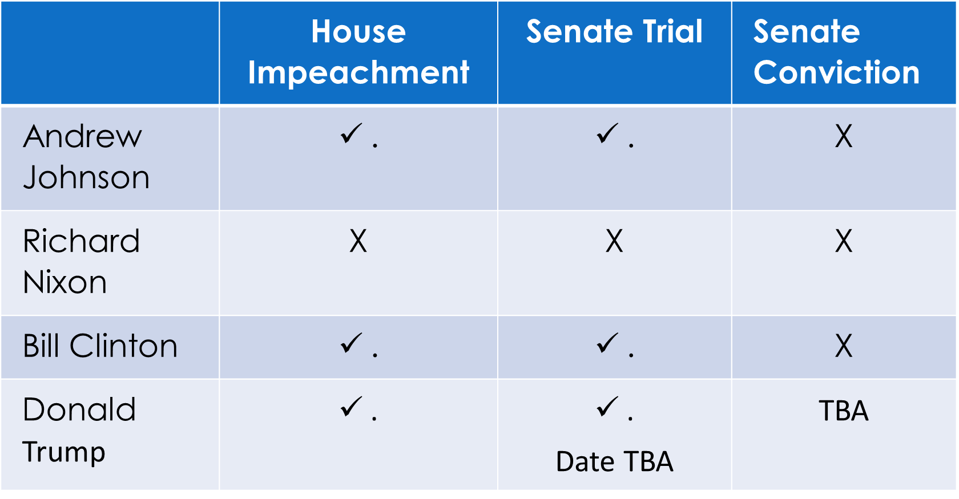

In conclusion
What we can retain is that God is great. He is indeed the great Palmoni. We have a clear understanding of prophecy and we can trust that our methodology, our method of studying the Bible is correct. The beginning 1868 shows us the end 2019. Now we need to confidently continue to look at how the impeachment will develop, and it will be a great testimony for the Levites even the Nethinims.

Prayer:
Dear Heavenly Father, thank you for not letting your children in darkness. You showed us the end from the beginning, and we are amazed on how your prophetic word is confirmed by present history. I pray we all take hold of the message so we will be a testimony for the Levites but also the Nethinims. Blessed our fellowship in this Sabbath day. In Jesus’ name. Amen

